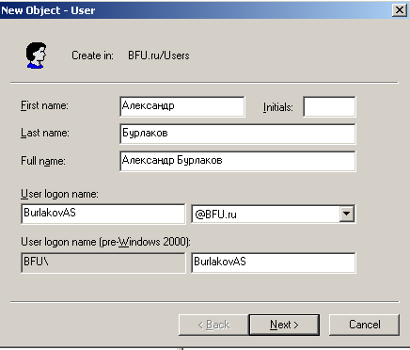

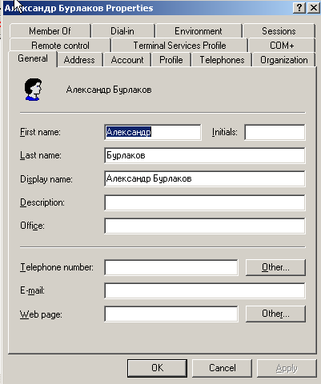

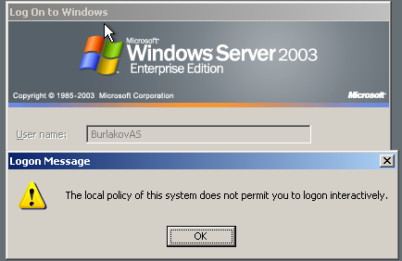

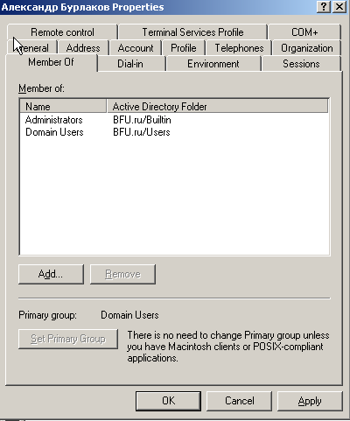

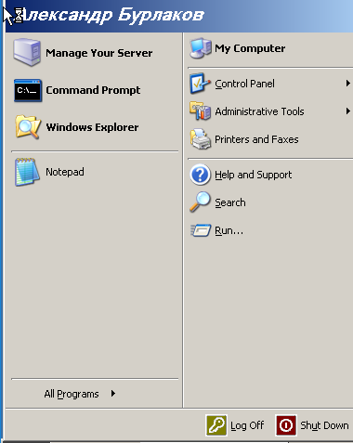

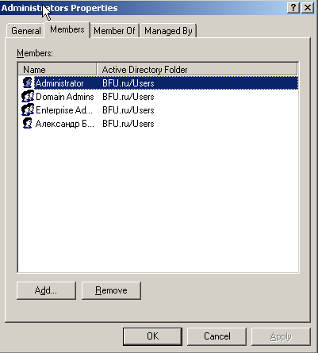

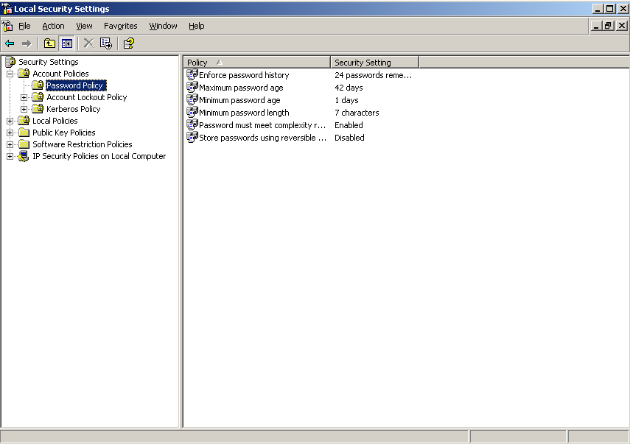

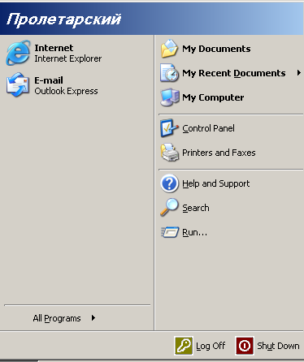

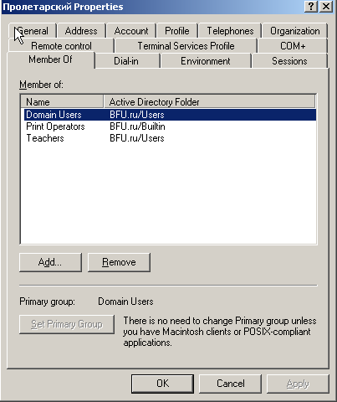

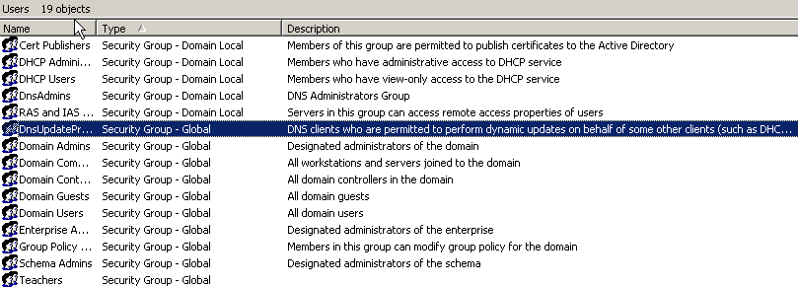

|  |  |  |  |
| --- | --- | --- | --- |
| Группа пользователей | Тип группы | Количество членов группы | Полное имя пользователей группы |
| Administrators | Domain Local | 4 | Administrators have complete and unrestricted access to the computer/domain |
| Incoming Forset Trust Builders | Domain Local | 2 | Members of this group can create incoming, one-way trusts to this forest |
| Perfomance Log Users | Domain Local | 1 | Members of this group have remote access to schedule logging of performance |
| Pre-Windows 2000 Comaptible Access | Domain Local | 1 | A backward compatibility group which allows read access on all users and groups |
| Users | Domain Local | 3 | --- |
| Windows Authorization Access Group | Domain Local | 1 | --- |